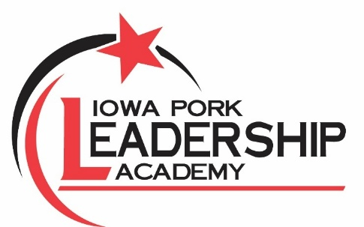

2027 Iowa Pork Leadership Academy Application
Applications due to Brielle Smeby no later than Nov. 30, 2027. Please email or scan
to bsmeby@iowapork.org OR mail to the Iowa Pork Producers Association (1636 N.W. 114th St. Clive, IA 50325). Call 515-225-7675 or email bsmeby@iowapork.org with any questions.

Reminder: The Iowa Pork Leadership Academy is geared toward working professionals involved in pork production. Students at the high school and college levels are welcome to be involved with Iowa Pork through our internships, youth team, collegiate team, and scholarships.

Please type or print clearly
Name:
Address: Cell Phone:
County : Email:

What is your involvement within pork production? (wean to finish, breed to wean, feeder to finish, etc., or allied industry)

Describe any involvement with the Iowa Pork Producers Association (committees, regional meetings or pork congress attendance, local county pork producers).

Describe your involvement with other community and agriculture activities.

As you think about pork production in the next five to 10 years, what do you feel will be the most critical issue?

Why do you want to participate in the Iowa Pork Leadership Academy? What do you hope to gain? If chosen, how would look to continue your involvement with IPPA after the program?

How did you hear about this program?

The 2027 Iowa Pork Leadership Academy will meet four to five times throughout the year, and participants will be recognized at the 2028 Iowa Pork Congress Master Pork Awards Banquet. Being able to attend all sessions is expected. We understand the time demands of those working in the pork industry, but full participation ensures the best experience for you and your classmates. By signing below as an applicant, you acknowledge your commitment to the program and intend to attend all sessions to the best of your ability.

Signature:

If you are aware of the sessions, you will miss due to prior established circumstances, please indicate as such below. These dates are subject to change.

Feb. 23-24, 2027 – National Pork Board Office (Clive)
March 23-24, 2027 – National Pork Producers Council Office (Urbandale)
June 21-24, 2027 – Washington, D.C. Trip (rely on congressional calendar)
Aug. 30 – Sept. 2, 2027 – North & South Carolina Trip
Jan. 25, 2028 — Iowa Pork Congress, Master Pork Awards Banquet

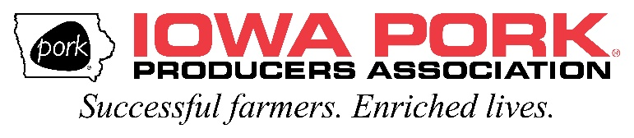
If there’s any questions about the application or Iowa Pork Leadership Academy, please contact Brielle Smeby at bsmeby@iowapork.org or call 515-225-7675

